TITLE: ML LAB – 09: Artificial Neural Networks (ANN)
Student Name: Mahir Desai
Roll No: 23FE10CSE00345
------------------------------------------------
AIM
Implement a basic Artificial Neural Network (ANN) using MLPClassifier and evaluate its performance using appropriate metrics.
------------------------------------------------
Experiment 1: Data Preprocessing
a) Load the dataset, encode labels, and split into training and testing sets
import pandas as pd
from sklearn.model_selection import train_test_split
from sklearn.preprocessing import StandardScaler, LabelEncoder
# Load data and preprocess
columns = ["sepal_length", "sepal_width", "petal_length", "petal_width", "species"]
data = pd.read_csv("iris/iris.data", header=None, names=columns)
encoder = LabelEncoder()
data['species'] = encoder.fit_transform(data['species'])
X = data.drop("species", axis=1)
y = data['species']
# Split and Scale
X_train, X_test, y_train, y_test = train_test_split(X, y, test_size=0.2, random_state=42)
scaler = StandardScaler()
X_train_scaled = scaler.fit_transform(X_train)
X_test_scaled = scaler.transform(X_test)
Preprocessing complete.
X_train shape: (120, 4)
X_test shape: (30, 4)
Experiment 2: ANN Implementation
b) Build and train an Artificial Neural Network (MLPClassifier)
from sklearn.neural_network import MLPClassifier
model = MLPClassifier(hidden_layer_sizes=(10, 8), max_iter=1000, random_state=42)
model.fit(X_train_scaled, y_train)
ANN training complete.
Experiment 3: Performance Evaluation
c) Evaluate the model using Accuracy, Confusion Matrix, and Classification Report
from sklearn.metrics import accuracy_score, confusion_matrix, classification_report
y_pred = model.predict(X_test_scaled)
print(f"Accuracy: {accuracy_score(y_test, y_pred):.4f}")
print("\nConfusion Matrix:\n", confusion_matrix(y_test, y_pred))
Accuracy: 1.0000
Confusion Matrix:
[[10 0 0]
[ 0 9 0]
[ 0 0 11]]
Experiment 4: Visualization
d) Visualize the Confusion Matrix and Training Loss Curve
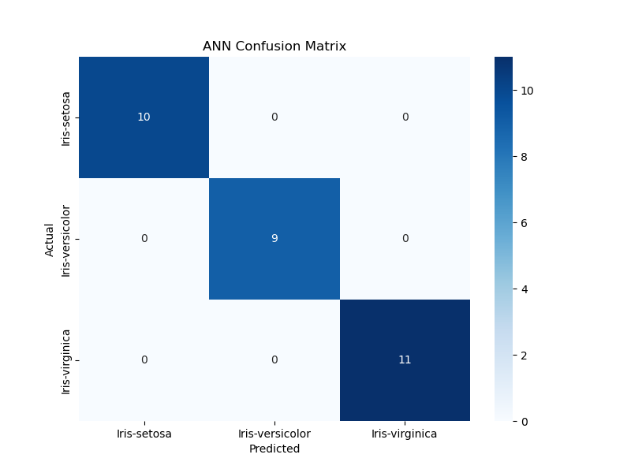
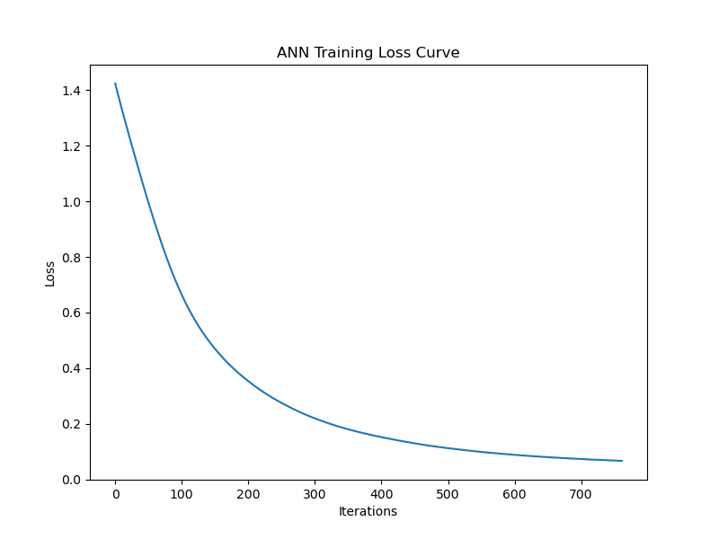
------------------------------------------------
Answers:
1. Feature scaling prevents bias toward features with larger ranges and ensures smoother gradient convergence.
2. Hidden layers extract increasingly complex features and non-linear patterns from raw inputs.
3. Activation functions introduce non-linearity, allowing the network to solve complex, non-linear problems.

